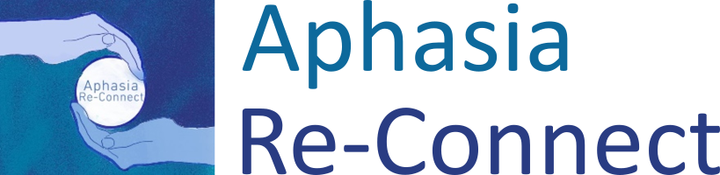
Registered Charity No: 1176125
www.aphasiareconnect.org
Email: info@aphasiareconnect.org

Application for voluntary work
Please print clearly in black ink

Voluntary Position applied for (please tick below):

Communication Support Volunteer o
Media team o
Fundraising o
Other o Date of application: _ _ / _ _ / _ _ _ _

Title: Surname: | Forenames:
Date of Birth:
Address: | ( Phone number:  E-mail:

Employment History (paid work, including voluntary work)

Previous and present employer Position held From To

Details of any Volunteering

Continue on separate sheet if necessary

Please give details of interests or hobbies:

Skills /qualities you can bring as a volunteer:

If you are interested in being a communication partner/ buddy – are there any other languages apart from English that you would be happy to use when buddying?

Why are you interested in Volunteering?

How did you hear about Aphasia Re-Connect?

Date you can begin voluntary work for Re-Connect:

Please tick times you are available to volunteer: | Morning | Afternoon
Monday

Tuesday
Wednesday
Thursday
Friday

Do you have a DBS?

o Yes

If yes, please select that all apply:
o Children
o Adults
o Children & Adults
o Enhanced

o No

References
Please give all relevant details of two independent employment/voluntary referees (not relatives), both of whom have agreed to provide a written reference for Re-Connect and confirm the email address to avoid any delay in your application. You can give either a phone number or email address, whichever you think they would prefer.

Full Name: Full Name:
Occupation: Occupation:
Relationship to you: Relationship to you:
Telephone: Telephone:
Email: Email:

Convictions

Have you ever been convicted of a criminal offence, including a spent conviction? YES/NO
If YES, please give details:-

(The Rehabilitation of Offenders Act 1974 requires you to reveal unspent convictions when working with vulnerable clients although disclosure will not necessarily prevent you from becoming a volunteer.)

Do you have a current DBS for working with vulnerable adults? YES/NO

Disability

Do you consider yourself to have a disability? YES/NO
If yes, please give details:-

How can we assist with any special needs to enable you to attend interview or carry out your duties?

Sign and date the declarations below:

I declare that the information given by me, to the best of my knowledge, is true and complete.

I agree to this information being kept confidentially by Aphasia Re-Connect under the Guidelines of the Data Protection Act.

NAME ........................................................................

SIGNED ......................................................................

DATE ..........................................................................

This application is for voluntary work only. Neither of us intends any employment relationship to be created either now or at any time in the future.

Please return to Aphasia Re-Connect, info@aphasiareconnect.org

Or call Sally on 07885 288 943 if you have any queries

